|  |  |  |
| --- | --- | --- |
| **Storyboard Template for Multimedia Product Development** | | |
| Client Name: FocuST Performance | | |
| Project Title: FocuST performance Commercial Website | | |
| Last Update: 12-9-2018 | | Name of Designer: Joel Mondal |
| Panel/Page ID: index.html (desktop) | | Panel/Page/Frame No: FocuST Performance |
| Description of Copy text: | FocuST Performance text: “Don’t be slow like this car, shop FocuST Performance today” + “12 days of Christmas Sale, Really awesome discount this December!!!”  Animated gif at the center of the page  Disclaimer at the bottom of the page.  Font: 'Montserrat', sans-serif  Font color: black, white, purple  Size (px): 16,14 | |
| User Interactions: | Navigation buttons on the top of each page. Links to pages such as the home page and the other six pages  Skip links on top of page | |
| Hyper Links: | index.html  shop.html  aboutus.html  Gallery.html  About.html  Contact.html  Cart.html  Graphicresources.html  Login.html | |
| Audio inclusion and controls: | None | |
| Video inclusion and controls: | Project 4 animated gif | |
| Color specifications: | Page background: carbon fiber  Navigation: black bar w/ white text  Body: translucent background  Header/Footer: black(header), solid black(footer), white(text)  Hyperlink: no custom color (maybe be bold and underlined), hovering over hyperlink will allow the link to be clicked  Font color: black, white, purple (skip links) | |
| Panel Layout | | |

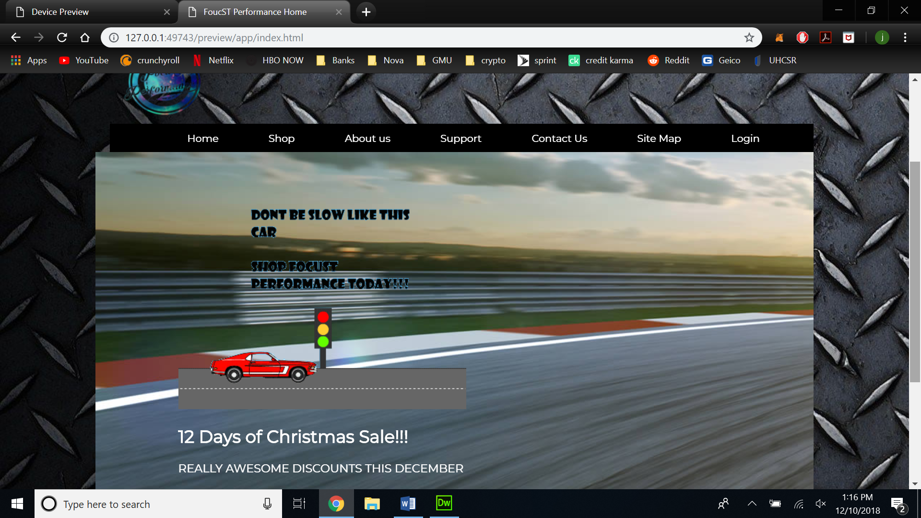

|  |  |  |
| --- | --- | --- |
| **Storyboard Template for Multimedia Product Development** | | |
| Client Name: FocuST Performance | | |
| Project Title: FocuST performance Commercial Website | | |
| Last Update: 12-9-2018 | | Name of Designer: Joel Mondal |
| Panel/Page ID: index.html (mobile) | | Panel/Page/Frame No: FocuST Performance |
| Description of Copy text: | FocuST Performance text: “Don’t be slow like this car, shop FocuST Performance today” + “12 days of Christmas Sale, Really awesome discount this December!!!”  Animated gif at the center of the page  Disclaimer at the bottom of the page.  Font: 'Montserrat', sans-serif  Font color: black, white, purple  Size (px): 16,14 | |
| User Interactions: | Navigation buttons on the top of each page. Links to pages such as the home page and the other six pages  Skip links on top of page | |
| Hyper Links: | index.html  shop.html  aboutus.html  Gallery.html  About.html  Contact.html  Cart.html  Graphicresources.html  Login.html | |
| Audio inclusion and controls: | None | |
| Video inclusion and controls: | Project 4 animated gif | |
| Color specifications: | Page background: carbon fiber  Navigation: black bar w/ white text  Body: translucent background  Header/Footer: black(header), solid black(footer), white(text)  Hyperlink: no custom color (maybe be bold and underlined), hovering over hyperlink will allow the link to be clicked  Font color: black, white, purple (skip links) | |
| Panel Layout | | |



|  |  |  |
| --- | --- | --- |
| **Storyboard Template for Multimedia Product Development** | | |
| Client Name: FocuST Performance | | |
| Project Title: FocuST performance Commercial Website | | |
| Last Update: 12-9-2018 | | Name of Designer: Joel Mondal |
| Panel/Page ID: Shop.html (desktop) | | Panel/Page/Frame No: Shop |
| Description of Copy text: | Items with their description and pricing  Disclaimer at the bottom of the page.  Font: 'Montserrat', sans-serif  Font color: black, white, purple  Size (px): 19,16,15,14 | |
| User Interactions: | Navigation buttons on the top of each page. Links to pages such as the home page and the other six pages  Skip links on top of page  Search bar to the left (non-functional)  Items sorted in their categories(non-functional) | |
| Hyper Links: | index.html  shop.html  aboutus.html  Gallery.html  About.html  Contact.html  Cart.html  Graphicresources.html  Login.html | |
| Audio inclusion and controls: | None | |
| Video inclusion and controls: | none | |
| Color specifications: | Page background: carbon fiber  Navigation: black bar w/ white text  Body: translucent background  Header/Footer: black(header), solid black(footer), white(text)  Hyperlink: no custom color (maybe be bold and underlined), hovering over hyperlink will allow the link to be clicked  Font color: black, white, purple (skip links)  Buttons: black w/ white font  Search bar: black(background), grey ( links), White | |
| Panel Layout | | |

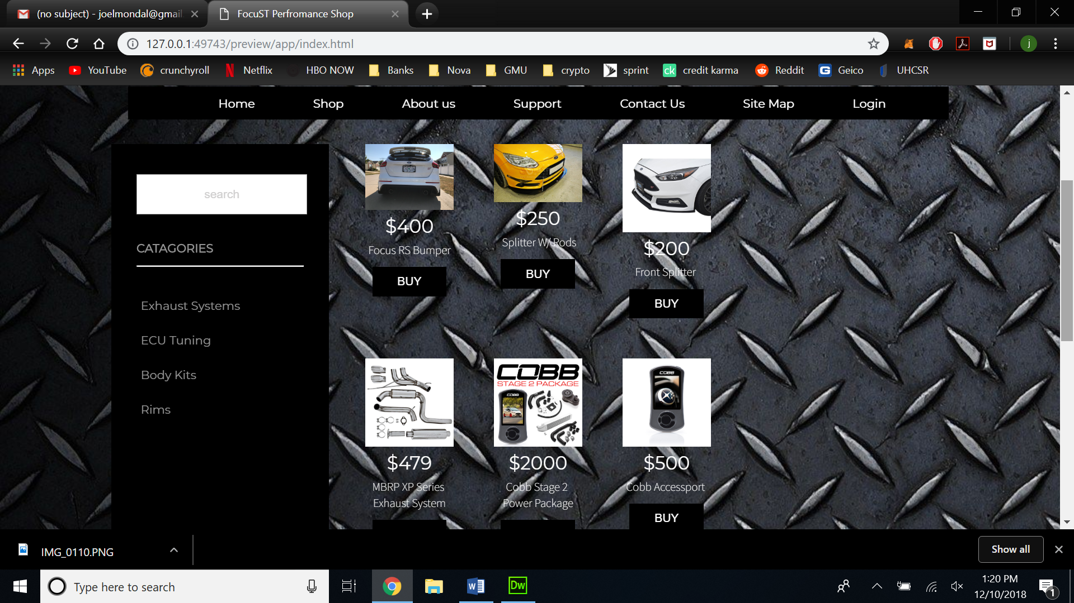

|  |  |  |
| --- | --- | --- |
| **Storyboard Template for Multimedia Product Development** | | |
| Client Name: FocuST Performance | | |
| Project Title: FocuST performance Commercial Website | | |
| Last Update: 12-9-2018 | | Name of Designer: Joel Mondal |
| Panel/Page ID: aboutus.html (desktop) | | Panel/Page/Frame No: About us |
| Description of Copy text: | About us statement: “The company FocuST performance enables customers to modify their Ford Focus St’s to their hearts desire; after all your car is said to be an extension of yourself. As we are a developing business, we offer the most competitive prices compared to any other online retailers. Shop FocuST Performance today!”  Disclaimer at the bottom of the page  Font: 'Montserrat', sans-serif  Font color: black, white, purple  Size (px): 19,16,15,14 | |
| User Interactions: | Navigation buttons on the top of each page. Links to pages such as the home page and the other six pages  Skip links on top of page | |
| Hyper Links: | index.html  shop.html  aboutus.html  Gallery.html  About.html  Contact.html  Cart.html  Graphicresources.html  Login.html | |
| Audio inclusion and controls: | None | |
| Video inclusion and controls: | none | |
| Color specifications: | Page background: carbon fiber  Navigation: black bar w/ white text  Body: translucent background  Header/Footer: black(header), solid black(footer), white(text)  Hyperlink: no custom color (maybe be bold and underlined), hovering over hyperlink will allow the link to be clicked  Font color: black, white, purple (skip links)  Buttons: black w/ white font  Search bar: black(background), grey (links), White | |
| Panel Layout | | |

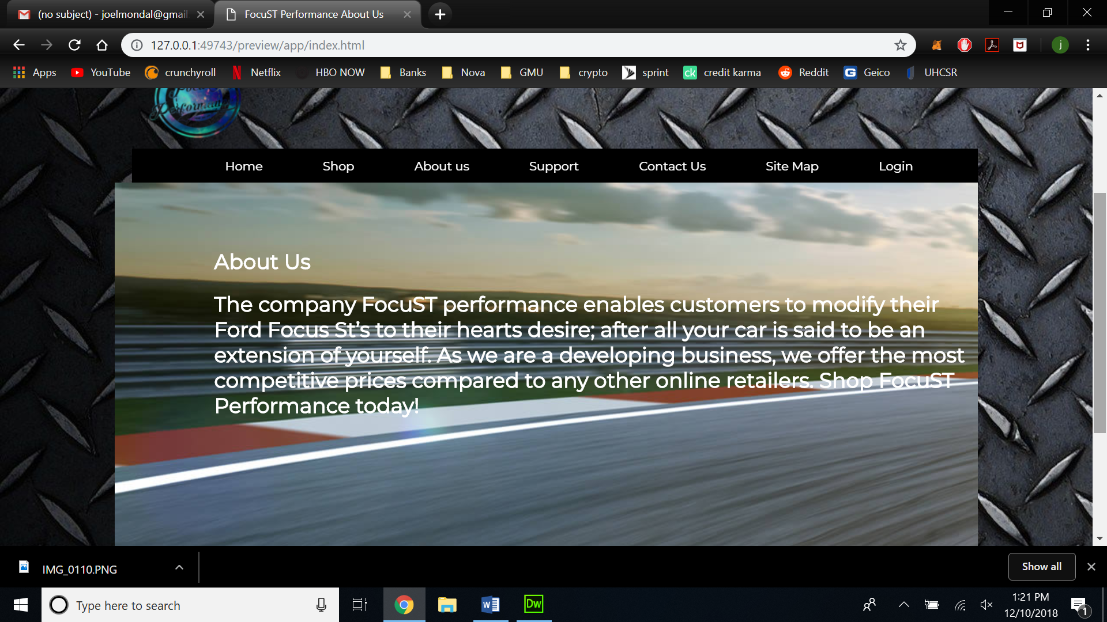

|  |  |  |
| --- | --- | --- |
| **Storyboard Template for Multimedia Product Development** | | |
| Client Name: FocuST Performance | | |
| Project Title: FocuST performance Commercial Website | | |
| Last Update: 12-9-2018 | | Name of Designer: Joel Mondal |
| Panel/Page ID: support.html (desktop) | | Panel/Page/Frame No: Support |
| Description of Copy text: | Images with links: “Official Ford Performance website “+” Information on Power Sates ”+”How to Forum”  Disclaimer at the bottom of the page  Font: 'Montserrat', sans-serif  Font color: black, white, purple  Size (px): 22,19,16,15,14 | |
| User Interactions: | Navigation buttons on the top of each page. Links to pages such as the home page and the other six pages  Skip links on top of page  Links that navigate to support pages | |
| Hyper Links: | index.html  shop.html  aboutus.html  Gallery.html  About.html  Contact.html  Cart.html  Graphicresources.html  Login.html | |
| Audio inclusion and controls: | None | |
| Video inclusion and controls: | none | |
| Color specifications: | Page background: carbon fiber  Navigation: black bar w/ white text  Body: translucent background  Header/Footer: black(header), solid black(footer), white(text)  Hyperlink: no custom color (maybe be bold and underlined), hovering over hyperlink will allow the link to be clicked  Font color: black, white, purple (skip links) | |
| Panel Layout | | |

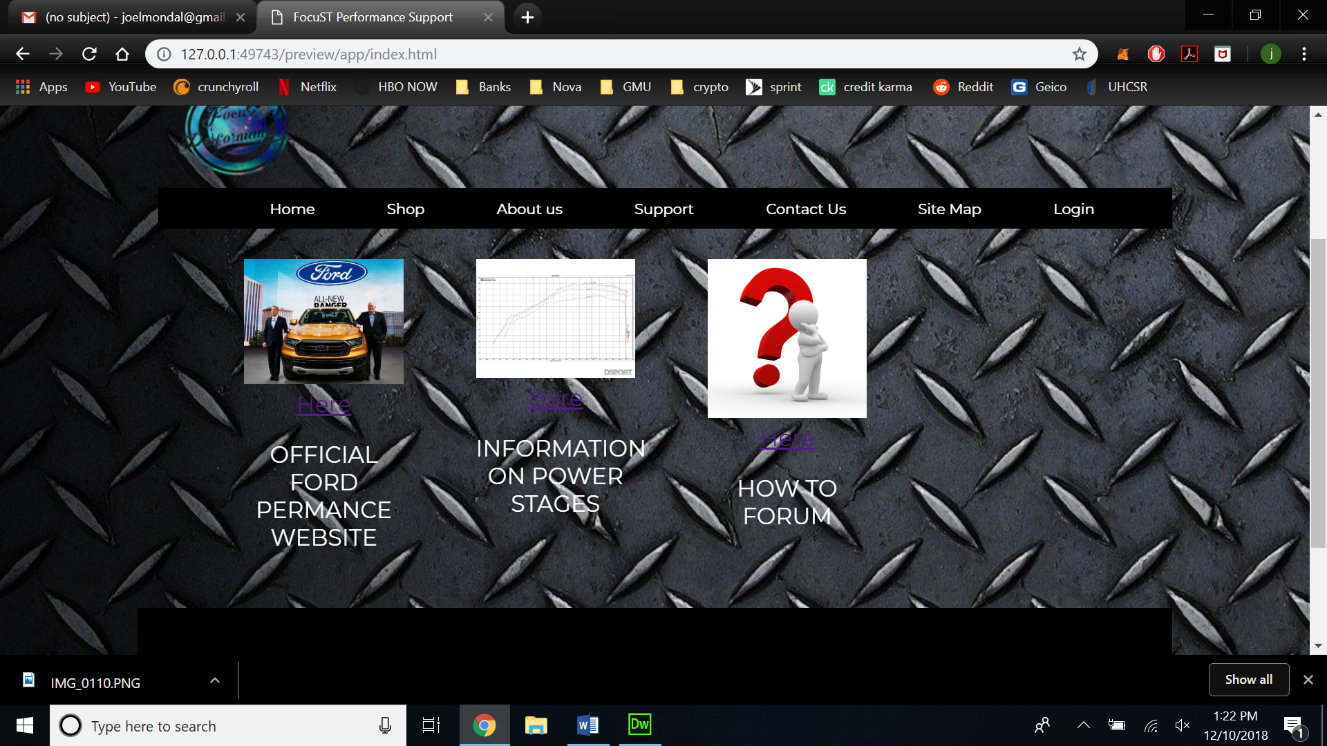

|  |  |  |
| --- | --- | --- |
| **Storyboard Template for Multimedia Product Development** | | |
| Client Name: FocuST Performance | | |
| Project Title: FocuST performance Commercial Website | | |
| Last Update: 12-9-2018 | | Name of Designer: Joel Mondal |
| Panel/Page ID: Contact Us (desktop) | | Panel/Page/Frame No: Contact Us |
| Description of Copy text: | Contact us phone number: (800) 111-Focus (fake)  Contact us email: FAKE  @GMAIL.COM  Disclaimer at the bottom of the page  Font: 'Montserrat', sans-serif  Font color: black, white, purple  Size (px): 22,19,16,15,14 | |
| User Interactions: | Navigation buttons on the top of each page. Links to pages such as the home page and the other six pages  Skip links on top of page  Google maps widget | |
| Hyper Links: | index.html  shop.html  aboutus.html  Gallery.html  About.html  Contact.html  Cart.html  Graphicresources.html  Login.html | |
| Audio inclusion and controls: | None | |
| Video inclusion and controls: | none | |
| Color specifications: | Page background: carbon fiber  Navigation: black bar w/ white text  Body: translucent background  Header/Footer: black(header), solid black(footer), white(text)  Hyperlink: no custom color (maybe be bold and underlined), hovering over hyperlink will allow the link to be clicked  Font color: black, white, purple (skip links)  Side bar: black(background), grey (links), White | |
| Panel Layout | | |

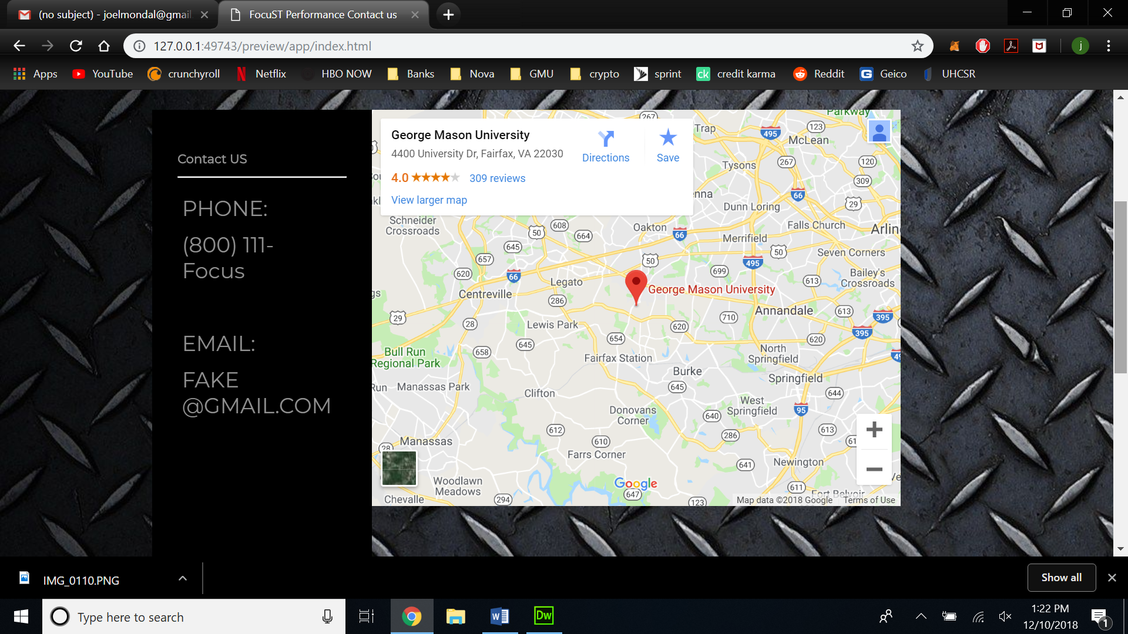

|  |  |  |
| --- | --- | --- |
| **Storyboard Template for Multimedia Product Development** | | |
| Client Name: FocuST Performance | | |
| Project Title: FocuST performance Commercial Website | | |
| Last Update: 12-9-2018 | | Name of Designer: Joel Mondal |
| Panel/Page ID: sitemap.html (desktop) | | Panel/Page/Frame No: Site Map |
| Description of Copy text: | Site map links: Home + shop + about us + support + sitemap +contact us + login  Disclaimer at the bottom of the page  Font: 'Montserrat', sans-serif  Font color: black, white, purple  Size (px): 22,19,16,15,14 | |
| User Interactions: | Navigation buttons on the top of each page. Links to pages such as the home page and the other six pages  Skip links on top of page  Links that navigate to all the webpages on the site | |
| Hyper Links: | index.html  shop.html  aboutus.html  Gallery.html  About.html  Contact.html  Cart.html  Graphicresources.html  Login.html | |
| Audio inclusion and controls: | None | |
| Video inclusion and controls: | none | |
| Color specifications: | Page background: carbon fiber  Navigation: black bar w/ white text  Body: translucent background  Header/Footer: black(header), solid black(footer), white(text)  Hyperlink: no custom color (maybe be bold and underlined), hovering over hyperlink will allow the link to be clicked  Font color: black, white, purple (skip links) | |
| Panel Layout | | |

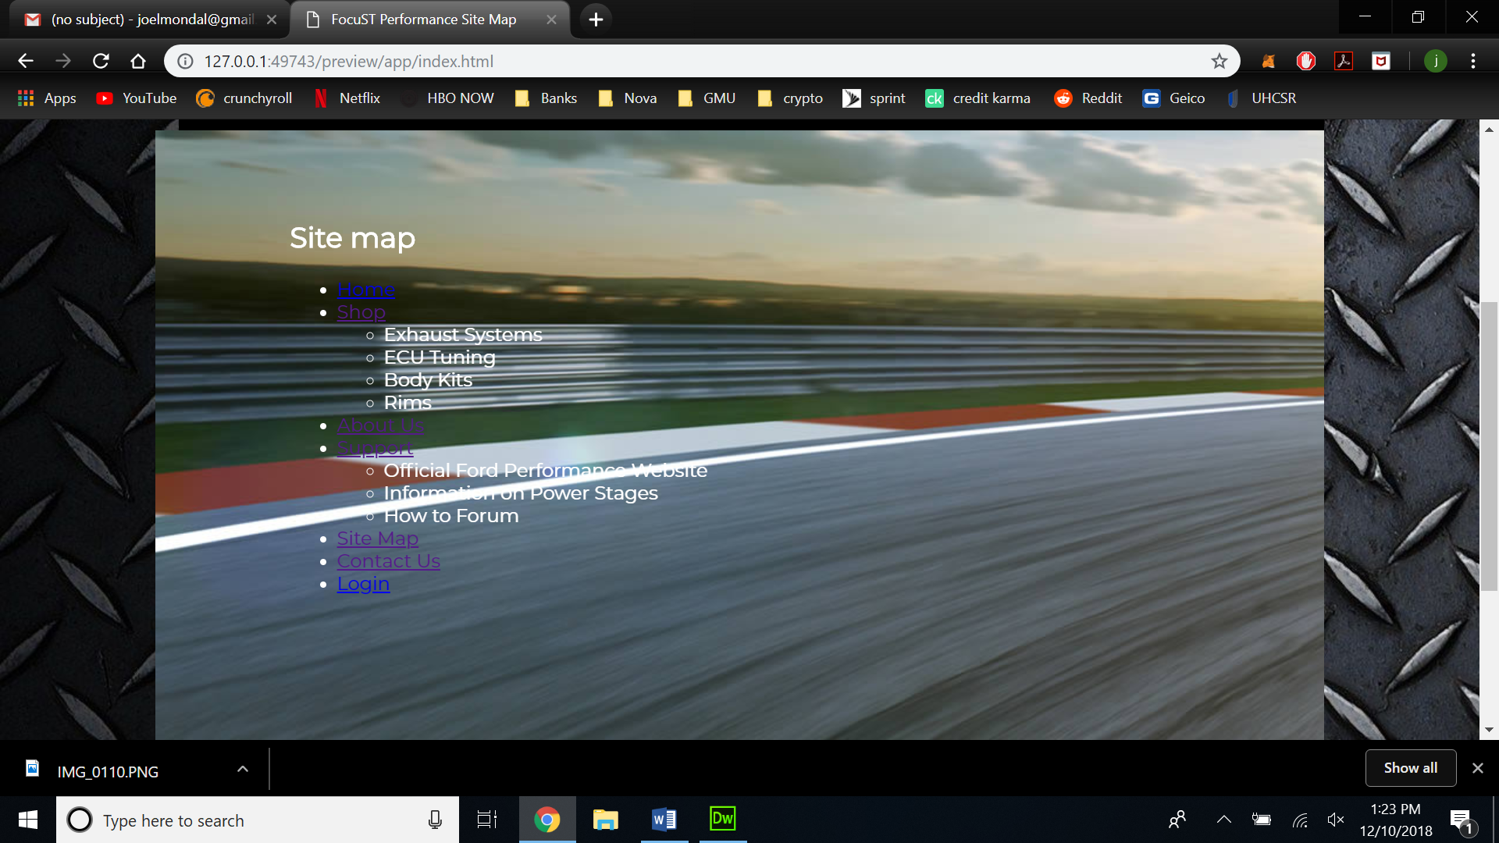

|  |  |  |
| --- | --- | --- |
| **Storyboard Template for Multimedia Product Development** | | |
| Client Name: FocuST Performance | | |
| Project Title: FocuST performance Commercial Website | | |
| Last Update: 12-9-2018 | | Name of Designer: Joel Mondal |
| Panel/Page ID: login.html (desktop) | | Panel/Page/Frame No: login |
| Description of Copy text: | Login box: username, password, and login  Font: "Roboto", 'Montserrat', sans-serif  Font color: black, white, purple  Size (px): 22,19,16,15,14 | |
| User Interactions: | Skip links on top of page  Login box that asks for user input username and password (non-functional) | |
| Hyper Links: | index.html  shop.html  aboutus.html  Gallery.html  About.html  Contact.html  Cart.html  Graphicresources.html  Login.html | |
| Audio inclusion and controls: | None | |
| Video inclusion and controls: | none | |
| Color specifications: | Page background: carbon fiber  Navigation: black bar w/ white text  Body: translucent background  Header/Footer: black(header), solid black(footer), white(text)  Hyperlink: no custom color (maybe be bold and underlined), hovering over hyperlink will allow the link to be clicked  Font color: black, white, purple (skip links)  Login box: grey (background), Black (button) | |
| Panel Layout | | |

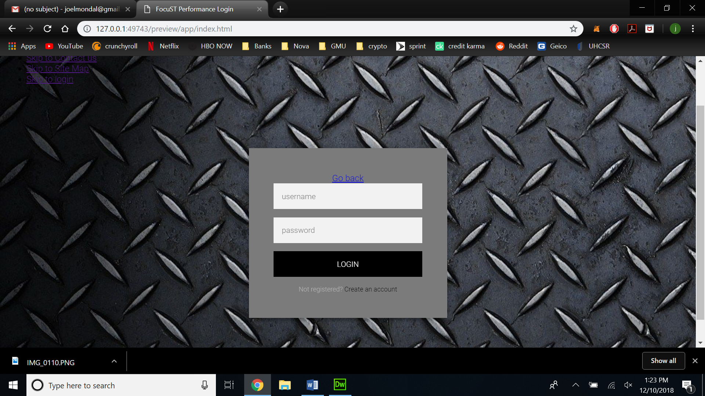

|  |  |  |
| --- | --- | --- |
| **Storyboard Template for Multimedia Product Development** | | |
| Client Name: FocuST Performance | | |
| Project Title: FocuST performance Commercial Website | | |
| Last Update: 12-9-2018 | | Name of Designer: Joel Mondal |
| Panel/Page ID: graphicresources.html (desktop) | | Panel/Page/Frame No: Graphical resources |
| Description of Copy text: | Text: Links in which I found my images  Font: "Roboto", 'Montserrat', sans-serif  Font color: black, white, purple  Size (px): 22,19,16,15,14 | |
| User Interactions: | Skip links on top of page  Nav bar with site links | |
| Hyper Links: | index.html  shop.html  aboutus.html  Gallery.html  About.html  Contact.html  Cart.html  Graphicresources.html  Login.html | |
| Audio inclusion and controls: | None | |
| Video inclusion and controls: | none | |
| Color specifications: | Page background: carbon fiber  Navigation: black bar w/ white text  Body: translucent background  Header/Footer: black(header), solid black(footer), white(text)  Hyperlink: no custom color (maybe be bold and underlined), hovering over hyperlink will allow the link to be clicked  Font color: black, white, purple (skip links) | |
| Panel Layout | | |

